User Manual

**University Bazaar System**



**Table of Content:**

1. Register
2. Login
3. Home
4. Create an Event
5. Clubs
6. Communication
7. Trade
8. Buy
9. Sell
10. Borrow
11. Exchange
12. Exchange Offer
13. Profile and Edit Profile
14. Search
15. Logout
16. Forget Password
17. **Register**

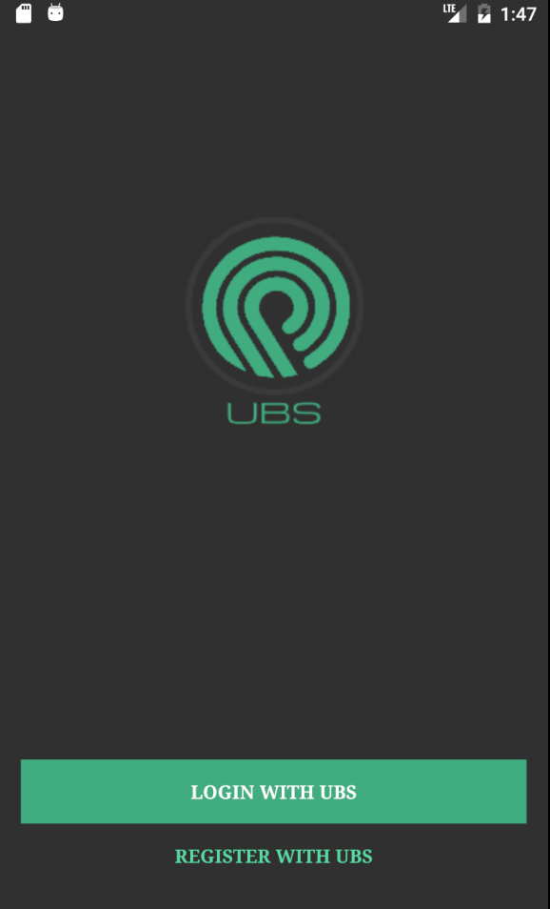 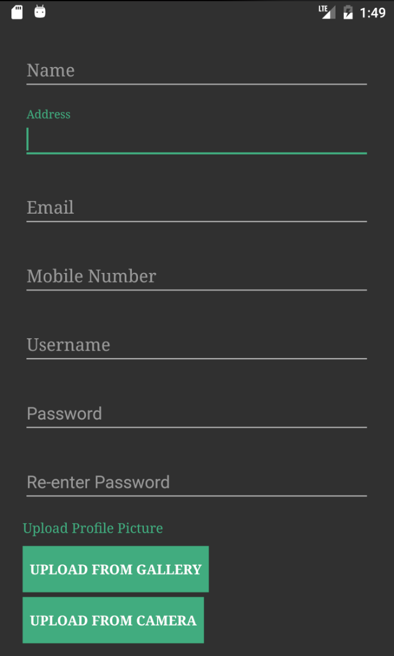

1.Tap in the **REGISTER WITH UBS**. 1. Provide all the **required information**.

2. Tap **upload from Gallery** or **Camera**.

3. Tap **Create Account.**

**2. Login**

 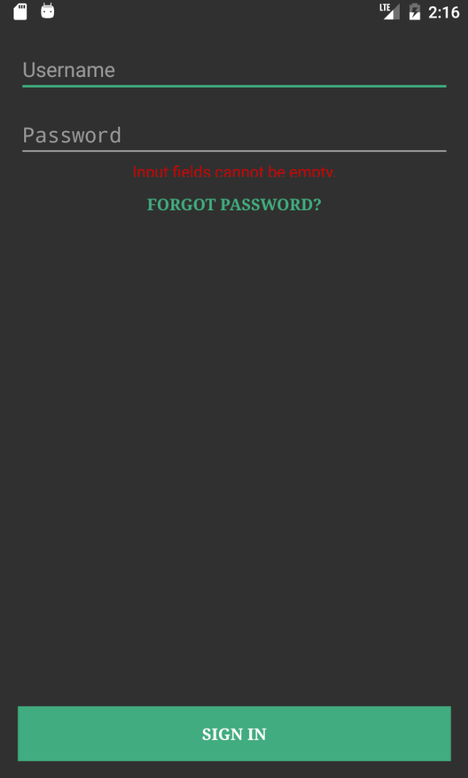

1. Tap in the **LOGIN WITH UBS**  1. Enter the **Username** and **Password** field.

2. Tap “**SIGN IN**” to log into the System.

**3. Home**

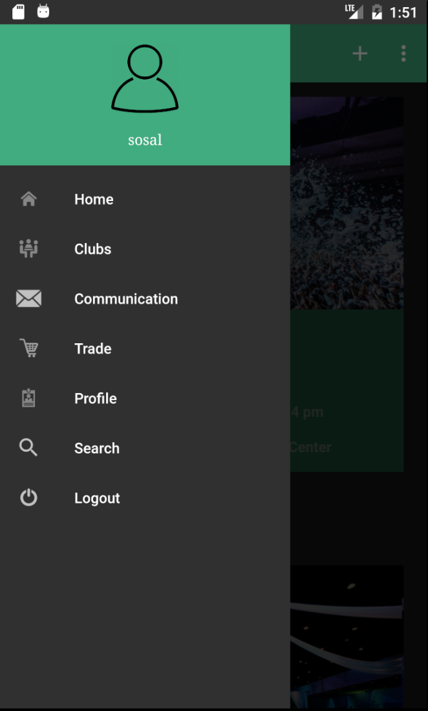

1. Tap on the left /Users/Sosal/Desktop/Screen Shot 2016-12-06 at 2.53.32 AM.png to go to **Home, Clubs, Communication,**

**Trade, Profile, Search, Logout**.

**4. Create an Event**

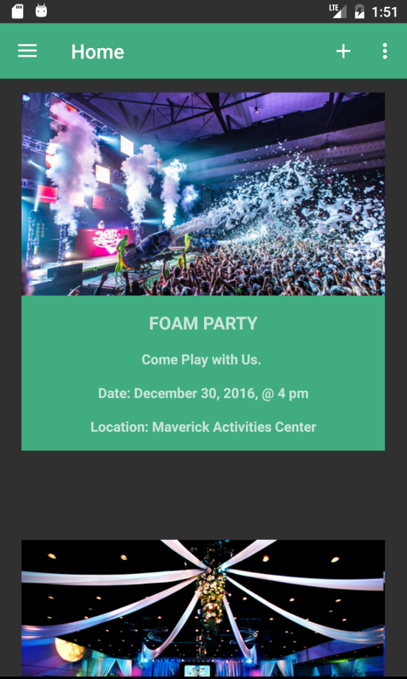 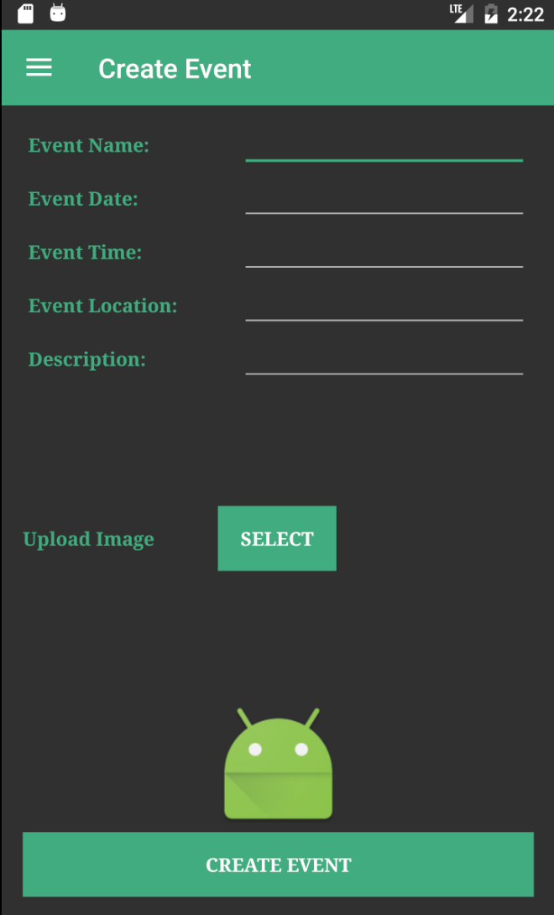

1. Tap towards the right corner on the 1. Fill all the information and tap SELECT

page indicating /Users/Sosal/Desktop/Screen Shot 2016-12-06 at 2.56.38 AM.png sign. **CREATE EVENT** Button to go to Gallery.

.

**5. Clubs**

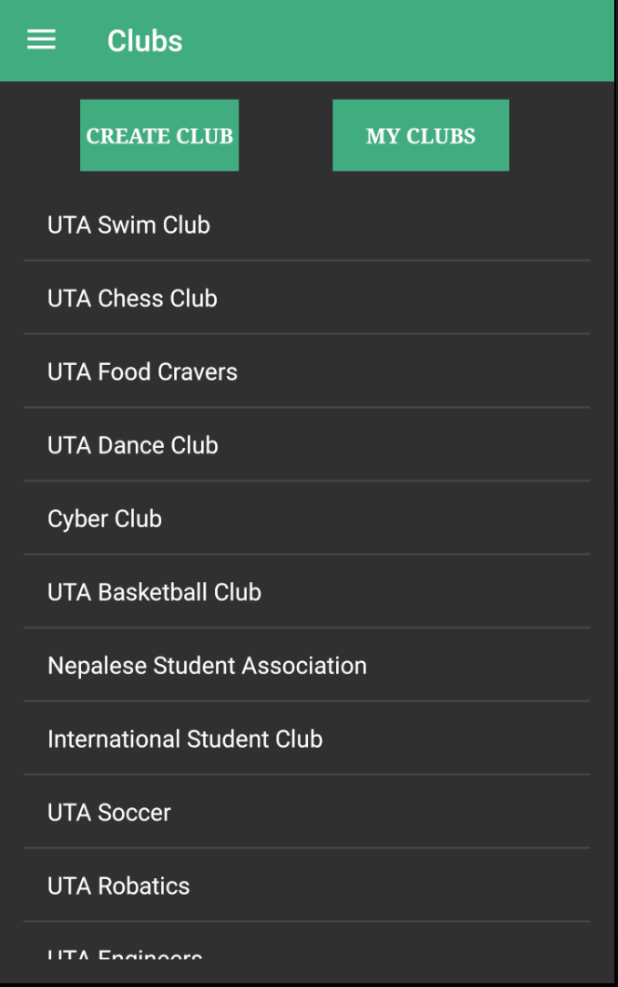 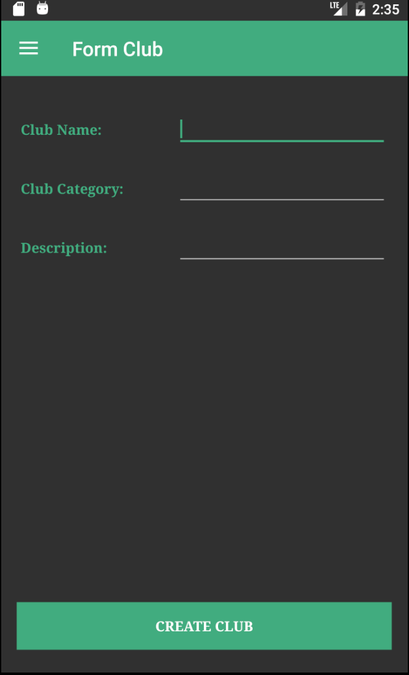

1.Tap **CREATE CLUB** on the left to create 1. Enter the information and Tap into

New Club. the **CREATE CLUB** to proceed.

**5. Communication**

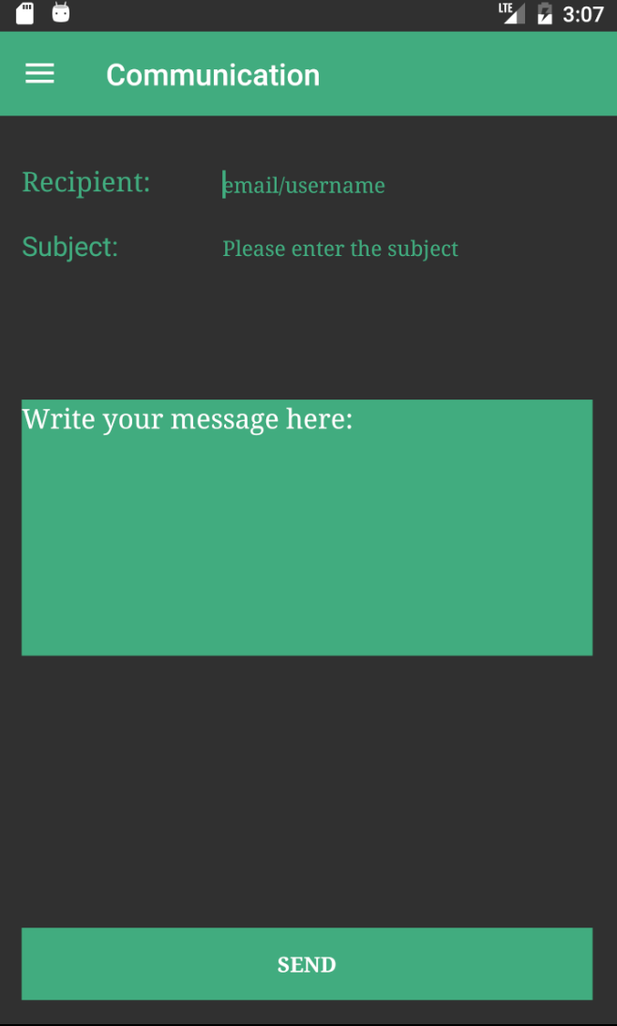

1. Tap into the **Recipient** to provide

Email/Username.

2. Provide the **Subject** field.

3. Enter the **message** inside the box field.

**6. Trade**

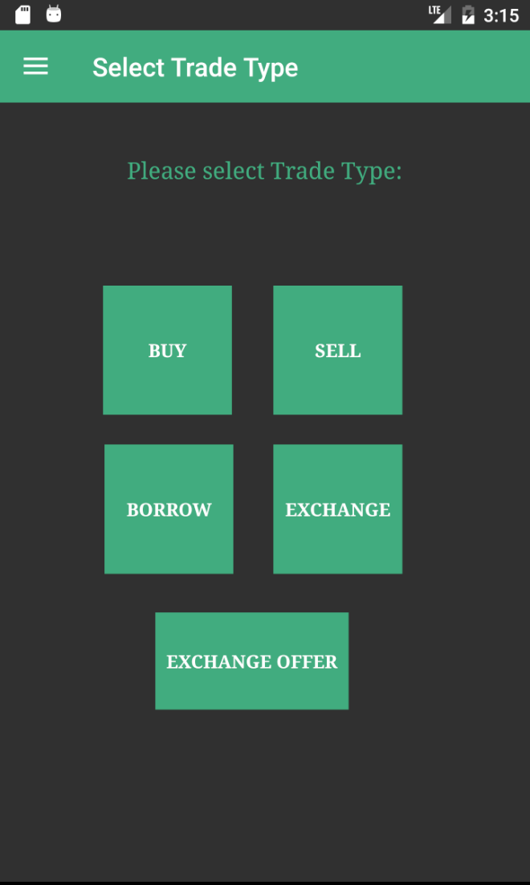

1. Inside the Trade Functionality Tap the **BUY**, **SELL**

**BORROW**, **EXCHANGE**, and **EXCHANGE** **OFFER**.

**7. Buy**

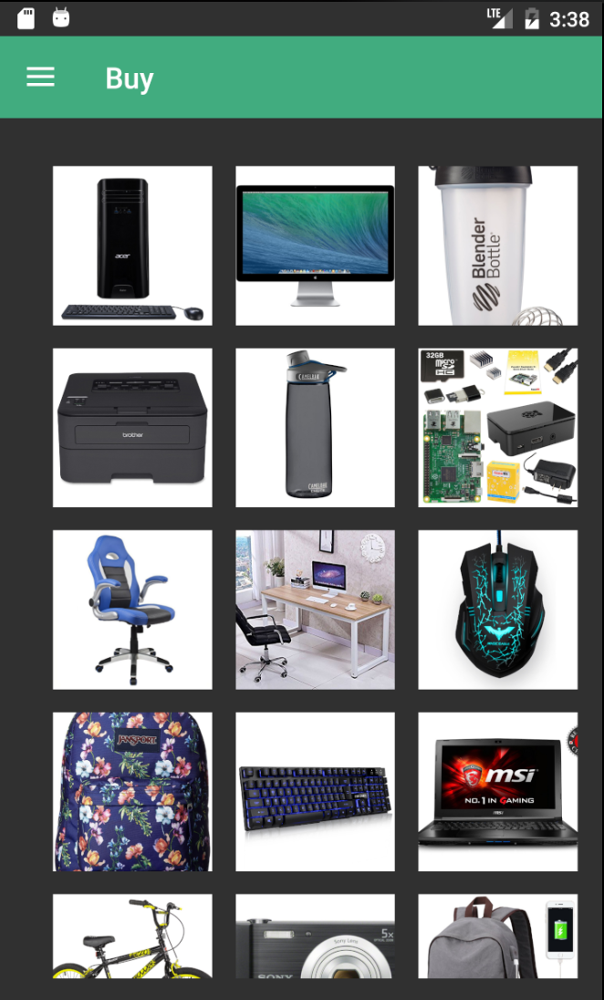 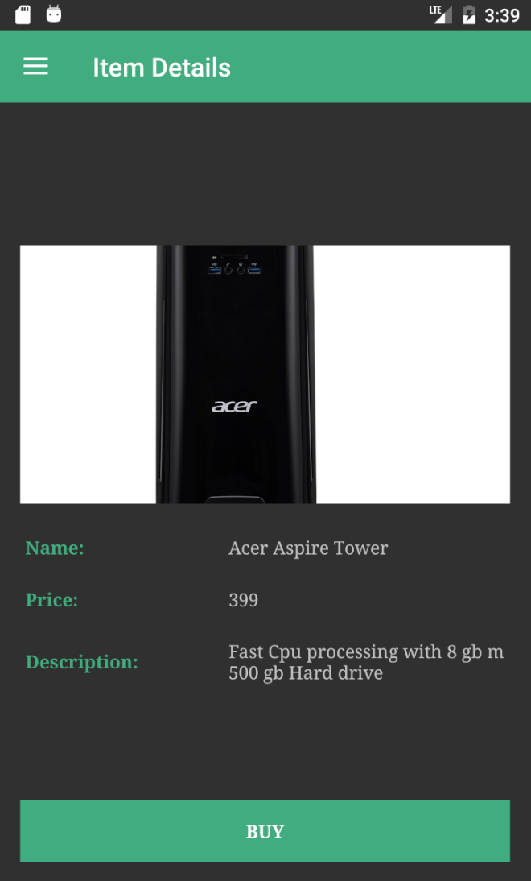

1. Tap into the any of the **Product**. 1. In the Item Details, Tap into the

**BUY** button to go to the shipping

Page.

2. Tap into the displayed **product**

**picture** to go to the Item Details.

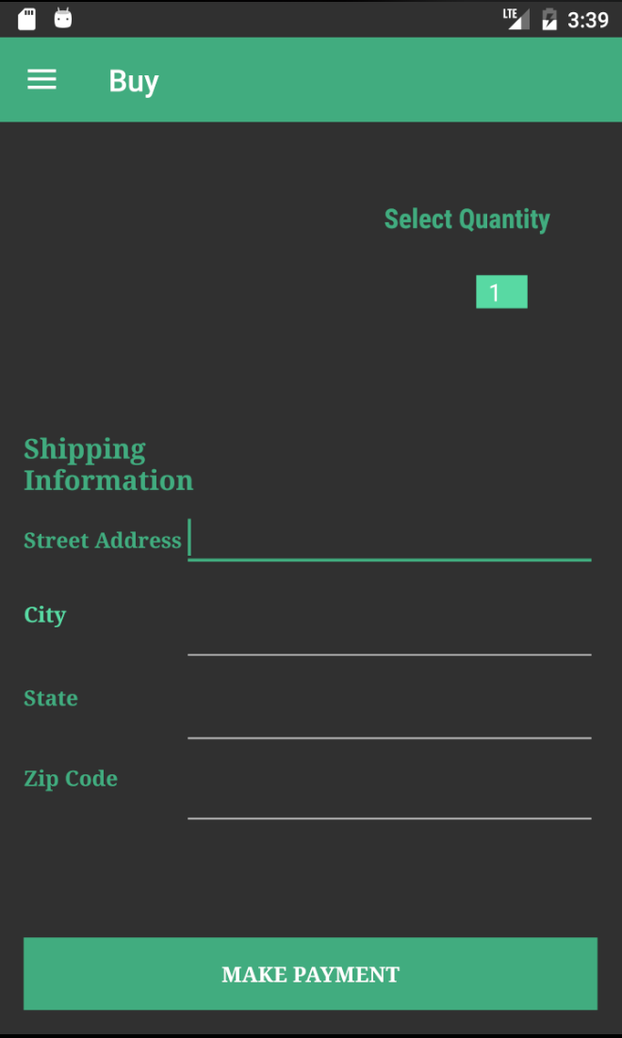 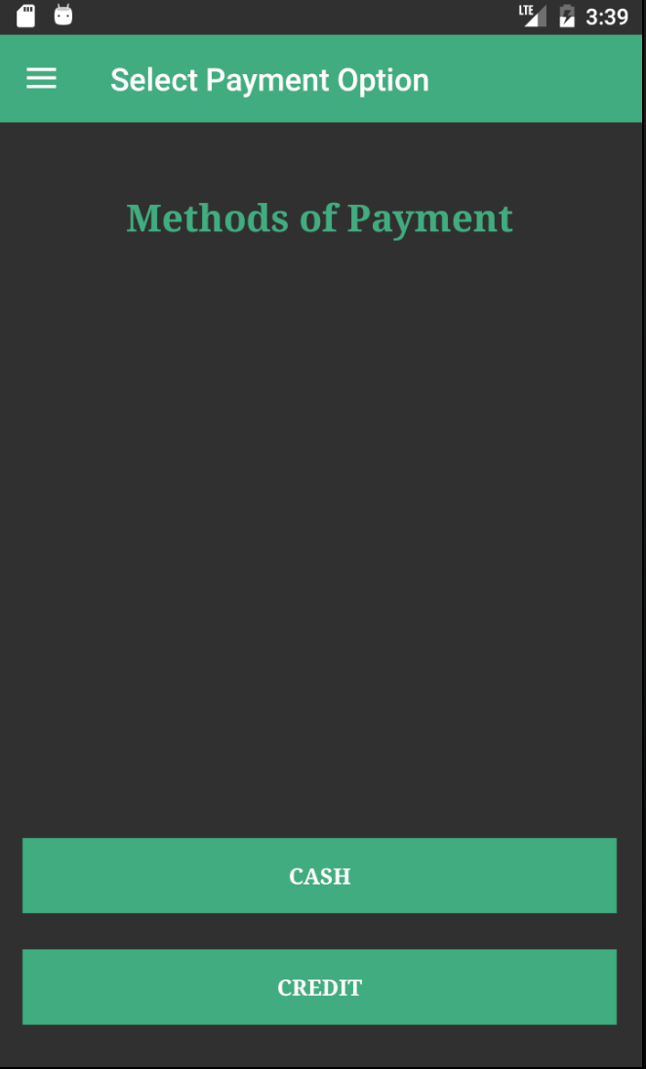

1. Tap to **Select Quantity** from the 1. Tap into the **CASH** or **CREDIT**

drop down button. Option for the Methods of Payment.

2. Fill the **detail information** needed.

3. Tap into the **MAKE PAYMENT**

button. This will take to the

Payment Option.

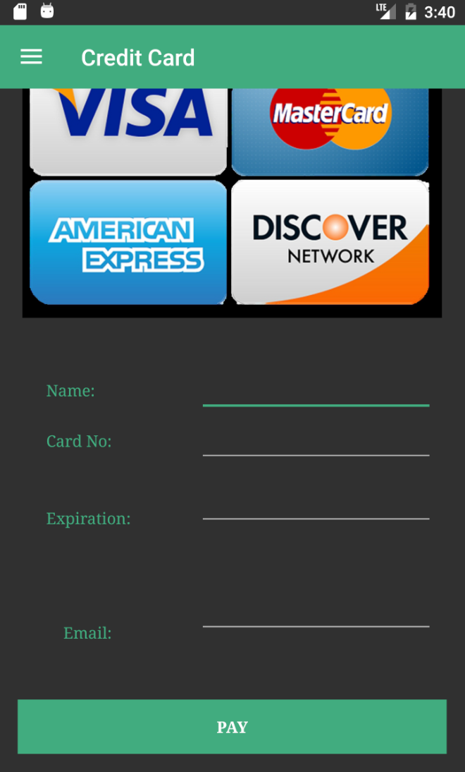 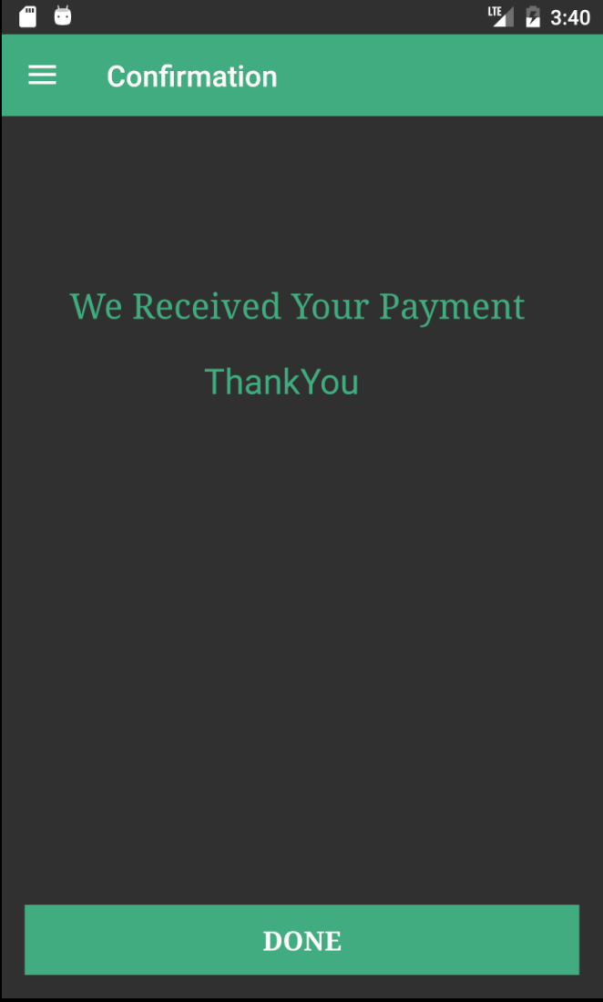

1. Enter the **Credit Card** Information. 1. Confirmation Page for the

Payment Process

2. Tap **PAY** to make Payment. 2. Tap **DONE** to go to the Home

Screen.

**8. Sell**

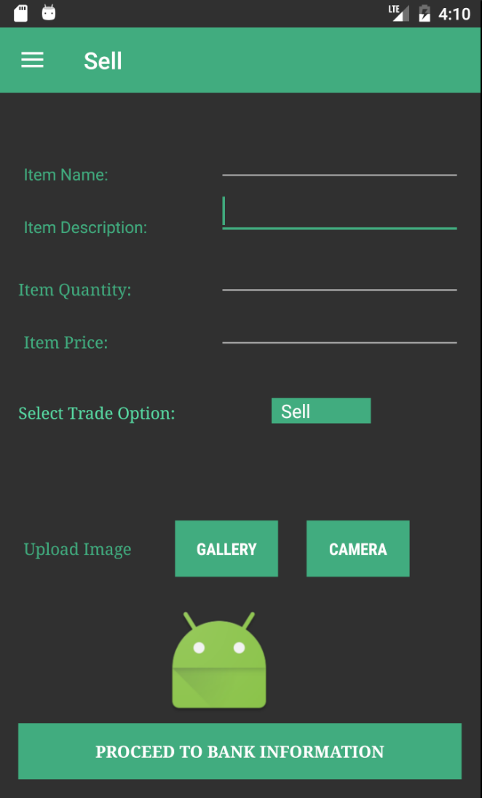 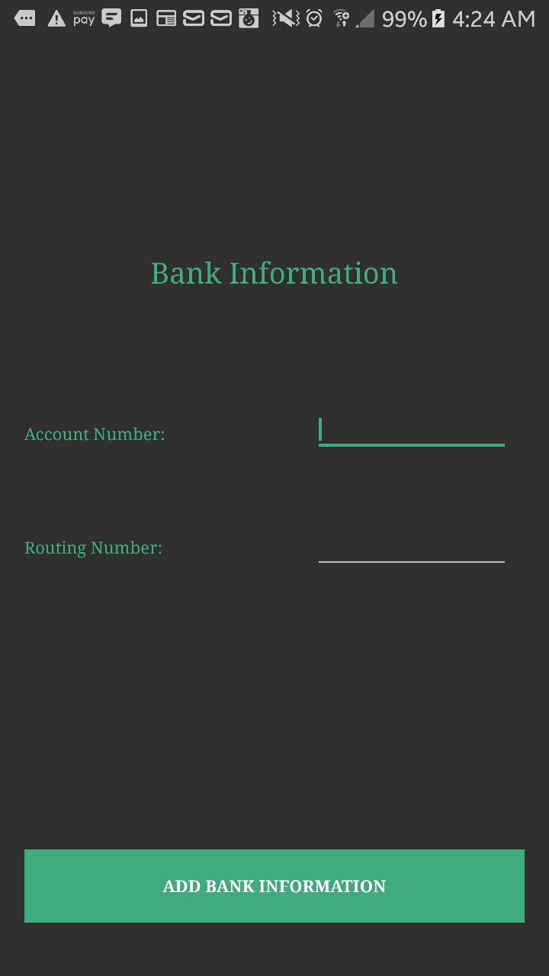

1. Provide all the **information** in the 1. Enter the **Account Number**.

Sell page.

2. Enter the **Name**, **Item Description**, 2. Enter **Routing Number**.

**Item Quantity**, **Item Quantity, Item Price,**

3. Select the **Sell** 3. Tap to **ADD BANK**

**INFORMATION.**

4. Upload the image by tapping **GALLERY**

or **CAMERA**

5. Tap, **PROCEED TO BANK INFORMATION**

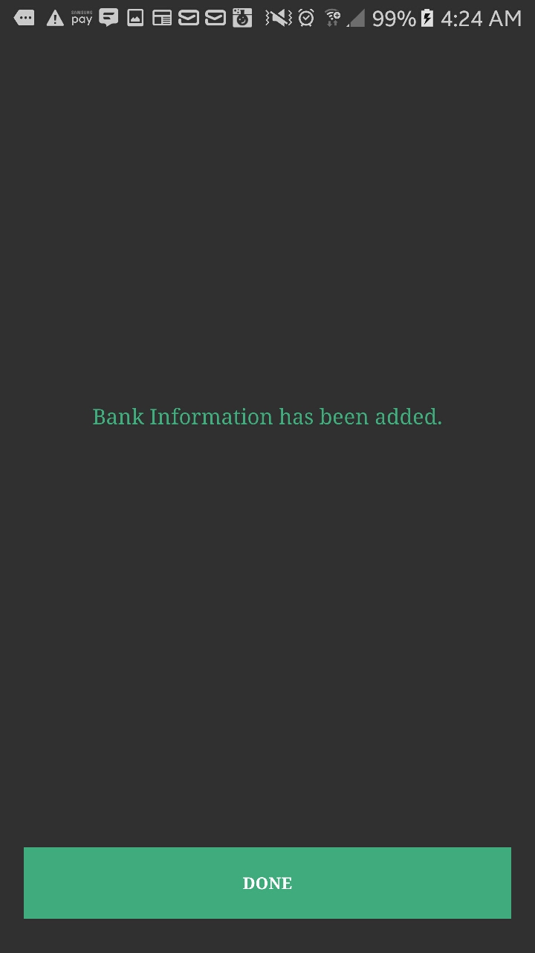

1. Tap, **DONE** to go to Home.

**9. Borrow**

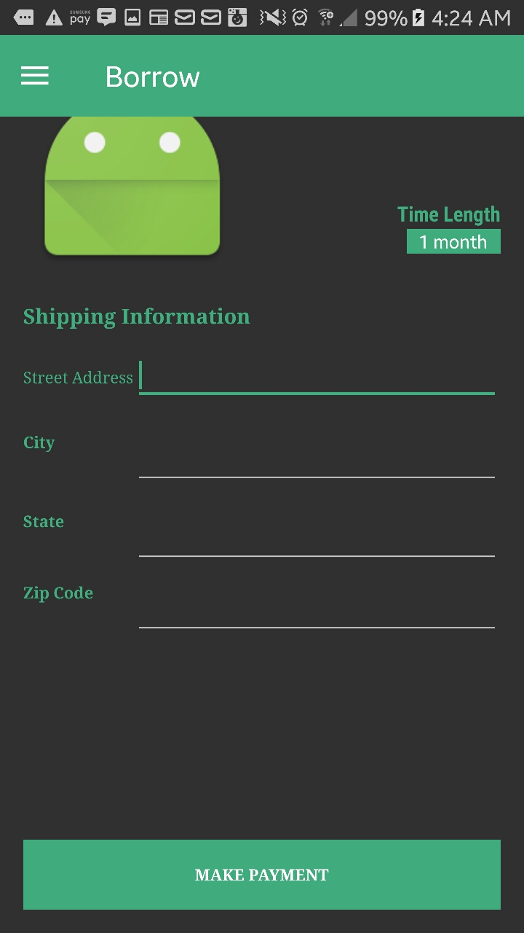 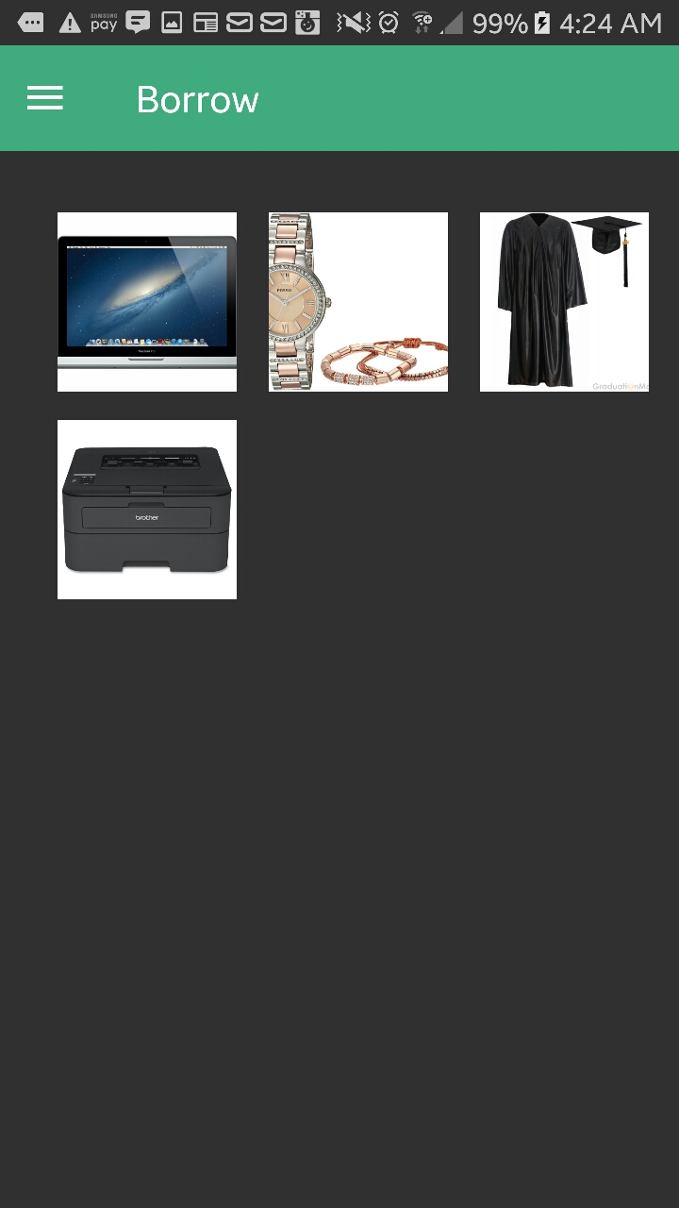

1. Tap to select from the desired 1. Tap to the displayed product

**Time Length.** **Picture** to go to the items details.

2. Tap to Enter the Shipping

Information. **Street Address**,

**City, State, Zip Code**.

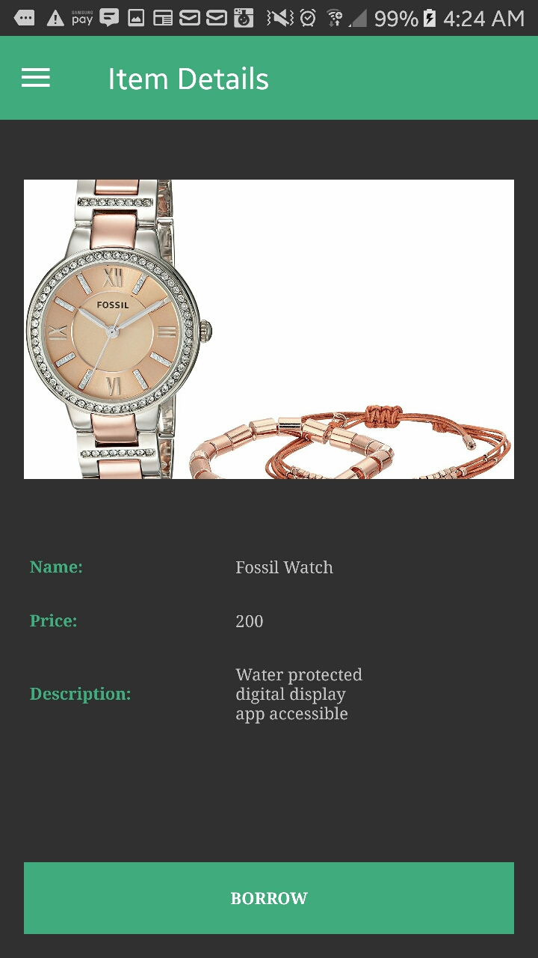 

1. Tap into the **BORROW** button 1. Tap to Select the **Time Length.**

to go to the Payment Page

2. Enter the **Shipping Information**.

3. Tap to **MAKE PAYMENT**.

 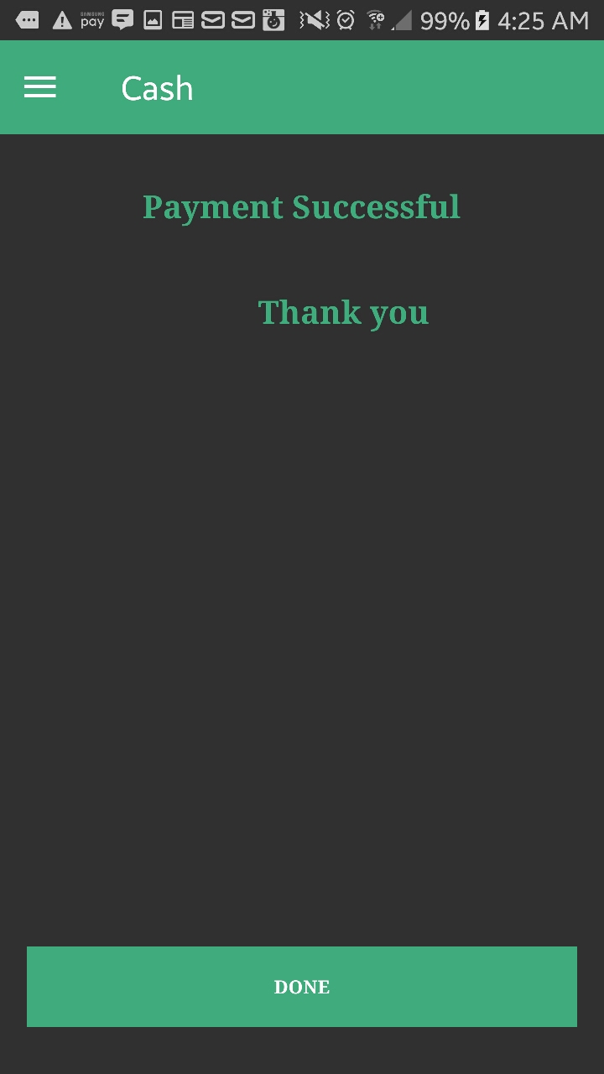

1. Tap to Choose the Method of 1. In **CASH** option**,** Tap **DONE** to go

Payment. **CASH** or **CREDIT** to the home.

**10. Exchange**

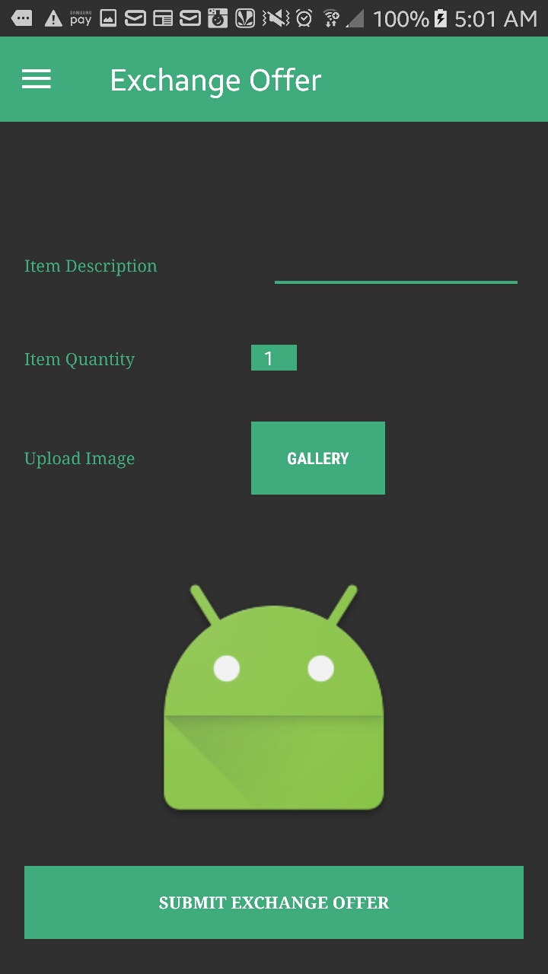 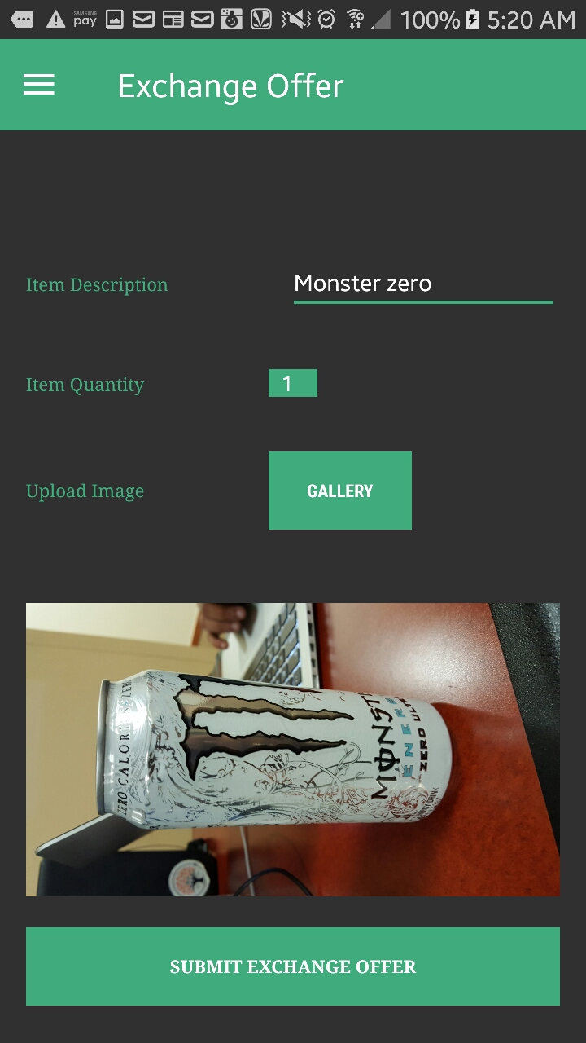

1. Tap to Enter the **Item Description**. 1. Tap, to **SUBMIT EXCHANGE**

**OFFER.**

2. Tap to Select the **Item Quantity**.

3. Tap to Upload Image from **GALLERY**

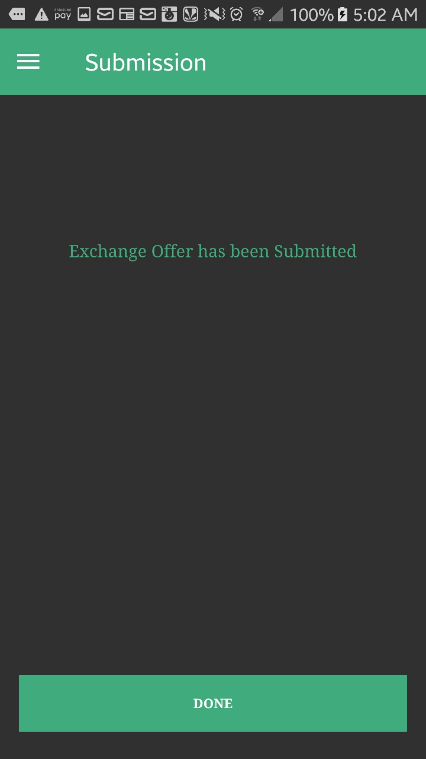

1. Tap, **DONE** that goes to the home page.

**11. Exchange Offer**

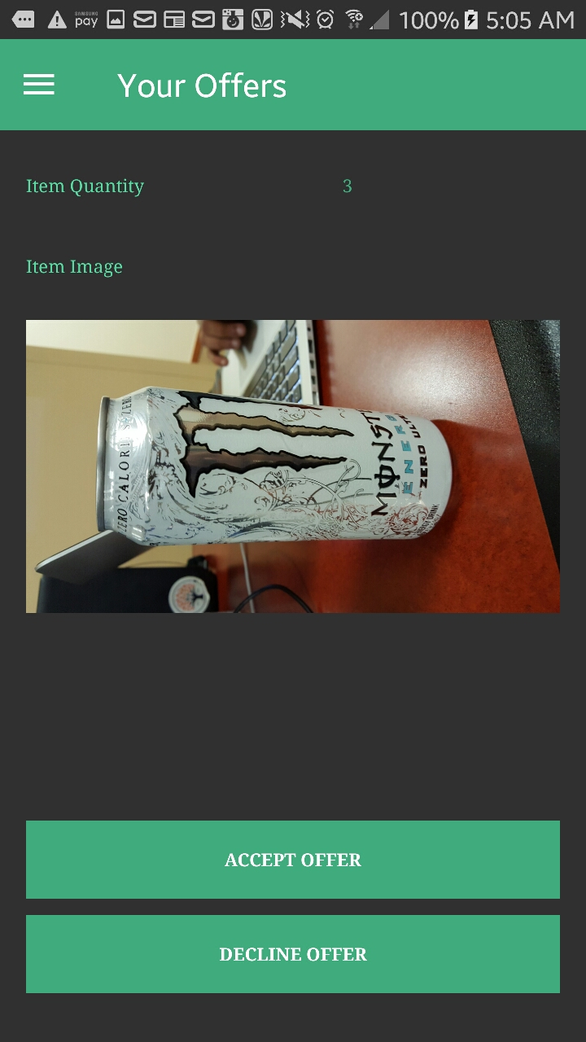 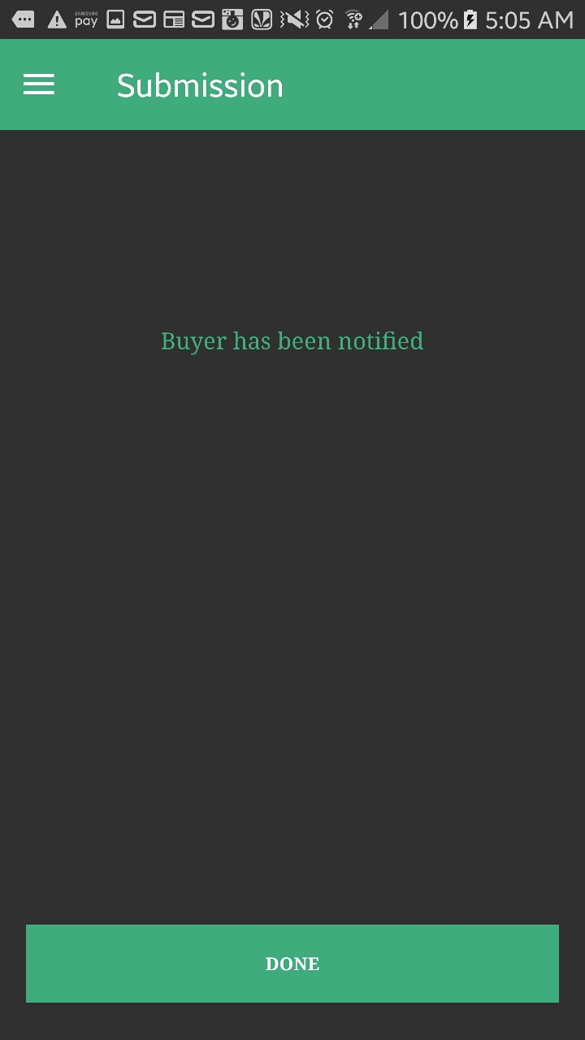

1. Tap to **ACCEPT OFFER** **OR** 1. Tap **DONE** to go to home.

**DECLINE OFFER**.

**12. Profile and Edit Profile**

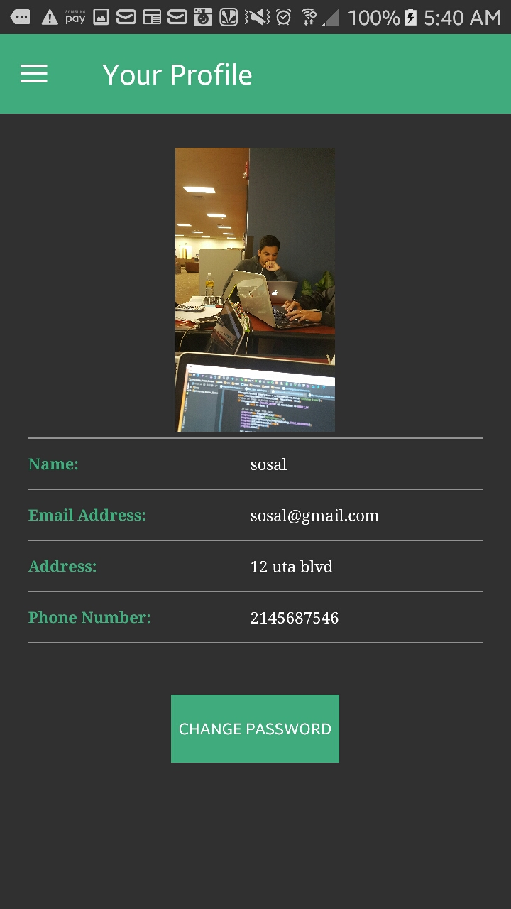 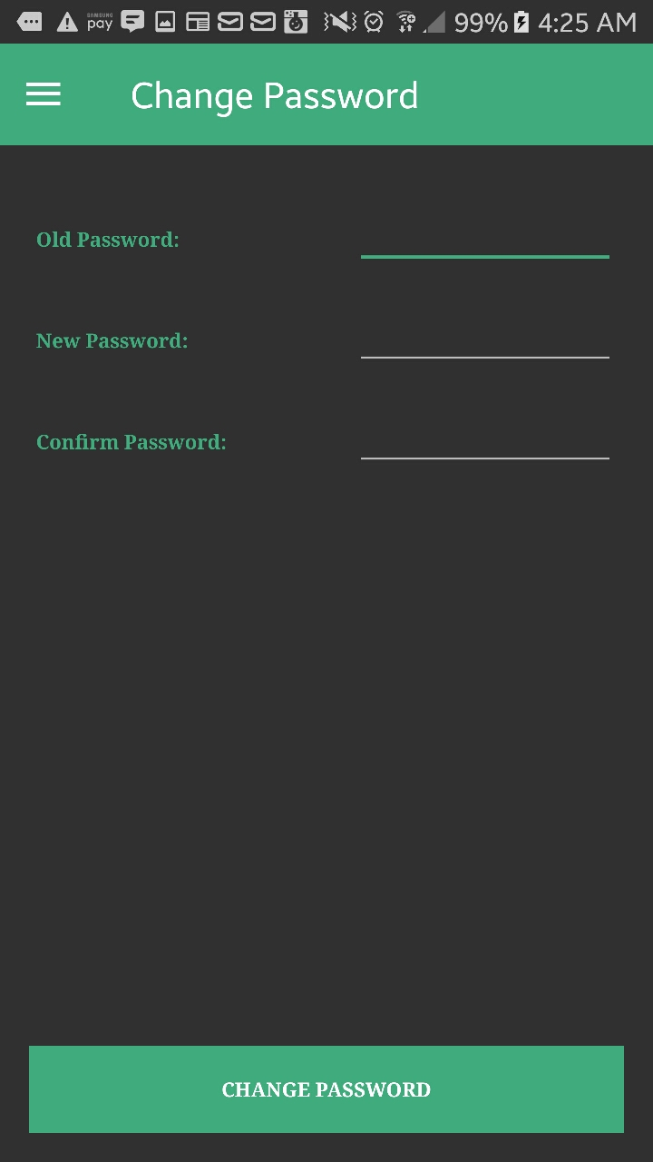

1. User Profile, Tap to Change any 1. Enter the **Old Password**, **New**

field as **NAME, EMAIL, ADDRESS, Password,** and **Confirm**

**PHONE NUMBER**. **Password**.

2. Tap **CHANGE PASSWORD.** 2. Tap **CHANGE PASSWORD**

to confirm.

**13. Search**

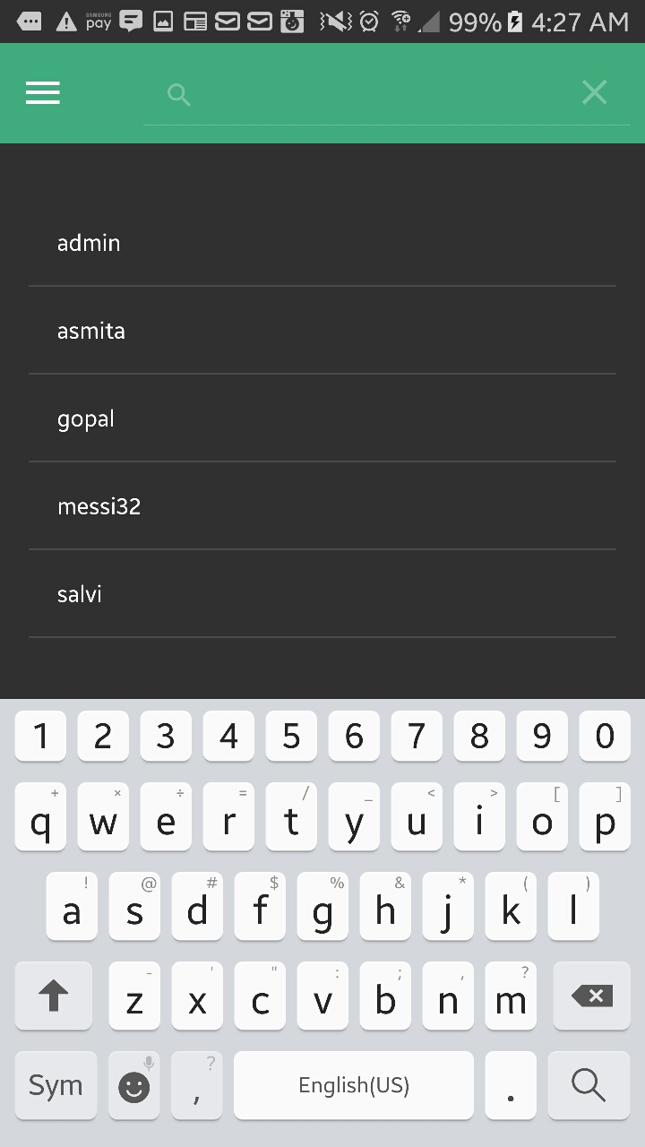 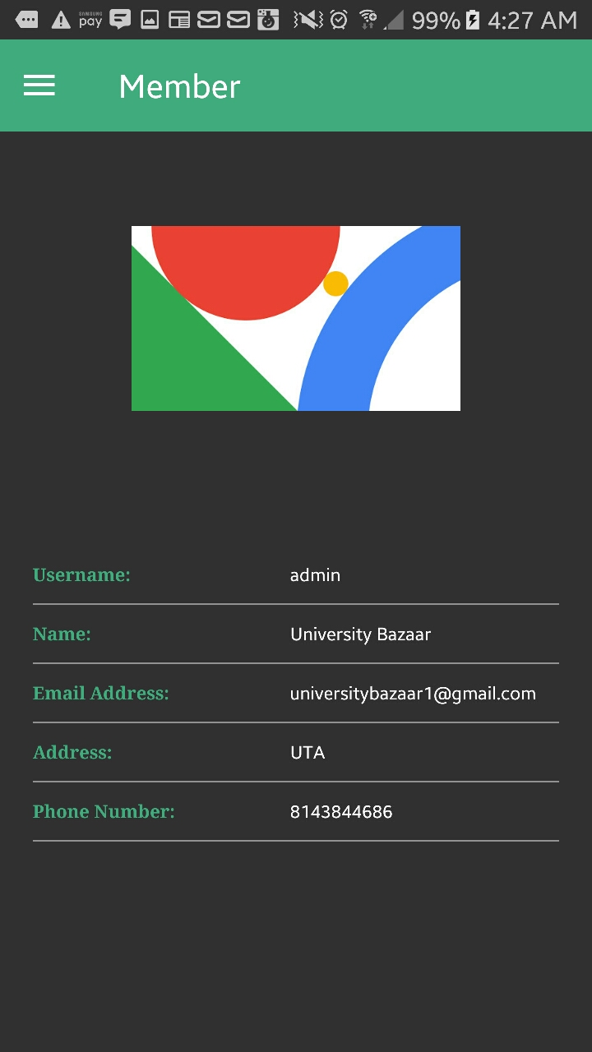

1. Tap the Search Info 1. Displays the **member** information

in the **Search Icon**.

2. Tap the **User name**

to populate the info.

**14. Logout**



1. Tap the **Logout** icon on the left to sign off.

**15. Forgot Password**

 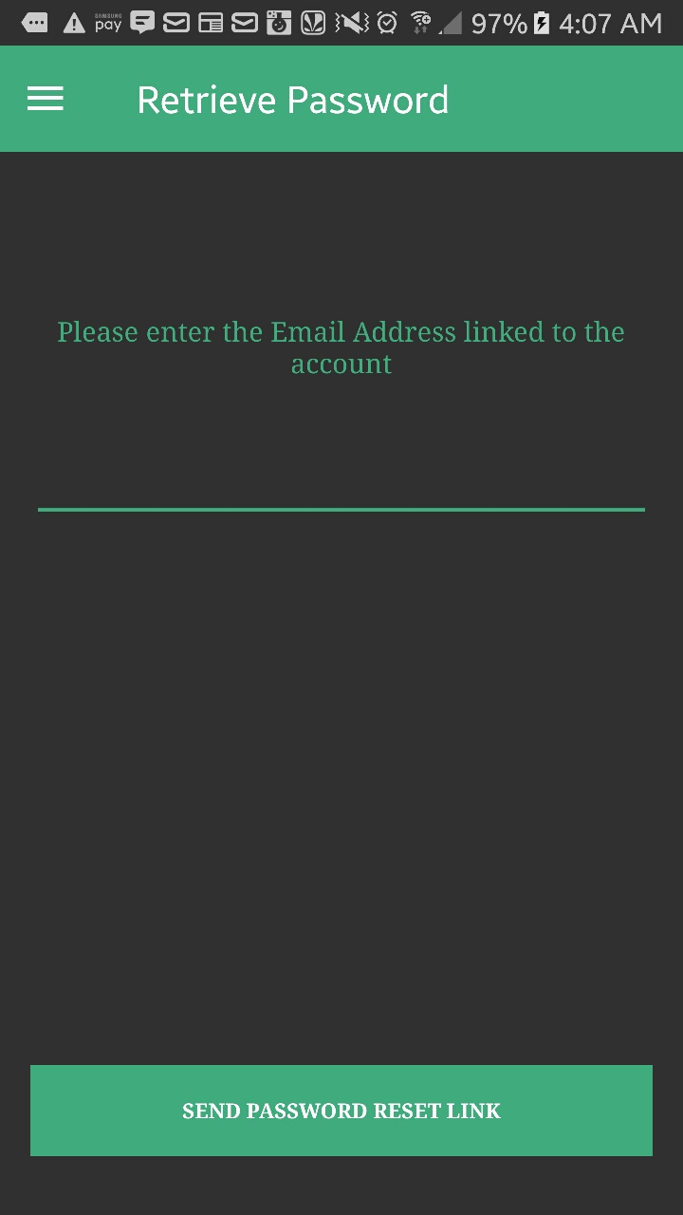

1. Tap the **FORGOT PASSWORD.** 1. To **Retrieve password**, Enter

the Email Address linked to your Account.

2. Tap the **SIGN IN** button. 2. Tap **SEND PASSWORD**

**RESET LINK**.

3. Check your **Email**.

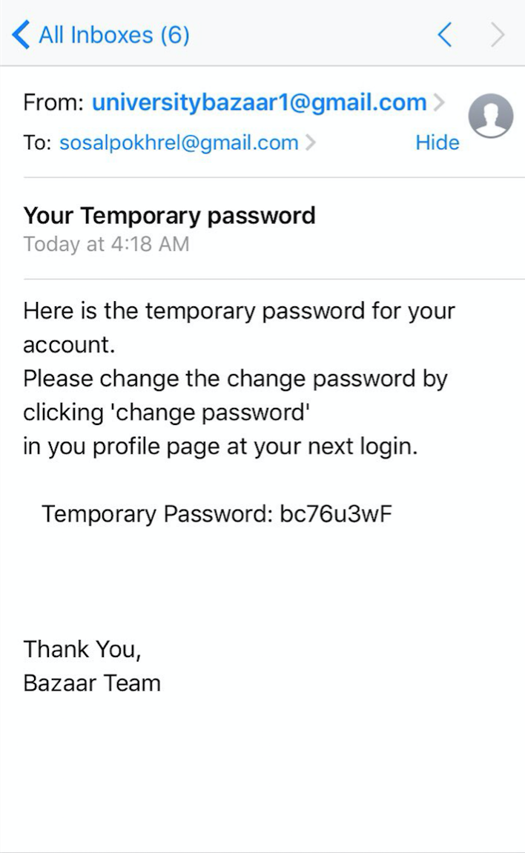

1. Use this **Temporary Password**

to login to your UBS.

2. Once the user is login, Change

your password in **Profile and Edit Profile**.